
Regulation:
A15
Sreenidhi Institute of Science and Technology
(An Autonomous Institution)
Code No: 5W102 Date : 01-03-2016
M.Tech. I-Year I-Semester Examinations, Feb/March- 2016 (Regular)
ADVANCED FINITE ELEMENT ANALYSIS (CAD/CAM)

Time: 3 Hours Max.Marks:75

Note: No additional answer sheets will be provided.

Part - A
Max.Marks:25

Answer all QUESTIONS.
- Differentiate transformation and iterative methods used for solution of eigen value problems3M
- Describe the transformation matrix used for space truss element 3M
- Write the assumptions that are considered in Kirchhoff plate theory 3M
- Differentiate lumped and consistent mass matrices. 3M
- Derive the element capacitance matrix for a bar element 3M
- State the governing differential equation for fluid flow problems in terms of stream function 2M
- Write the characteristics of stiffness matrices 2M
- Discuss the boundary conditions that are to be satisfied in plates 2M
- State the governing differential equation for radiation heat transfer problems. 2M
- For the space truss elements shown in Fig-1, the global displacements at node 2 have been determined to be d_{2x} = 4 mm, d_{2y} = 12 mm, and d_{2z}= 16 mm. Determine the displacement along the local axis at node 2 of the elements. The coordinates, in meters, are shown in the figure 2M
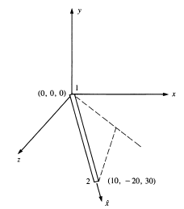

Part – B
Max.Marks:50
ANSWER ANY FIVE QUESTIONS. EACH QUESTION CARRIES 10 MARKS.
- Solve the following equations using Gauss elimination method
4x₁+2x₂-2x₃-8x₄=4
x₁+2x₂+x₃=2
0.5x₁-x₂+4x₃+4x₄=10
-4x₁-2x₂-x₄=0
2. Deduce the global stiffness matrix for the following truss shown in Fig-2 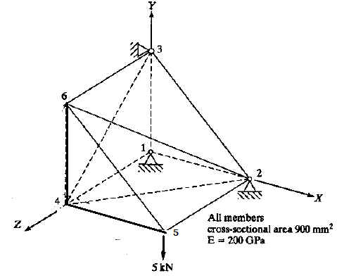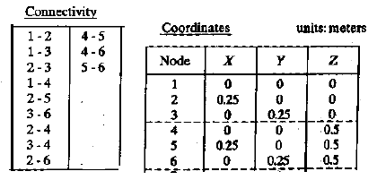

Fig-2

3. A triangular element is subjected to a transverse load of 1000 N as shown in Fig-3. Calculate the transverse displacement and stress developed in it by idealizing one element. Assume E=205 GPa, 𝜈=0.33 and thickness=10 mm.
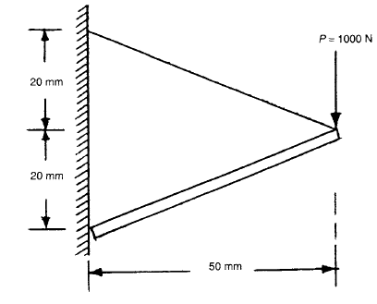
Fig-3

- Calculate the natural frequencies of a stepped beam shown in Fig-4.
Element-1: Cross sectional area= 100 mm²; Young’s modulus=200 GPa, Density=7800 Kg/m³
Element-2: Cross sectional area= 50 mm²; Young’s modulus=70 GPa, Density=2800 Kg/m³
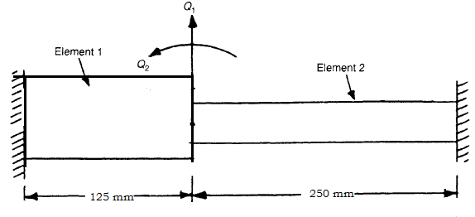
Fig-4

- Formulate the equations for finding transient temperature distribution for the shown fin in Fig-5. The left side base temperature is 140⁰C. The ambient temperature T₀=40⁰C. Length of pin(L)=50 mm. Diameter of fin=10 mm. Convection heat transfer coefficient(h)=2000 W/m²-⁰C.Thermal conductivity(k)= 380 W/m-⁰ C, ρc=2200 Joules/m⁰C. Δt=2 minutes.
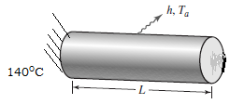
Fig-5

- For the one-dimensional flow through the porous medium shown in Fig-6 with fluid flux at the right end, determine the potentials at one-third and two-thirds of the length. Also determine the velocities in each element. Take A= 2 m².

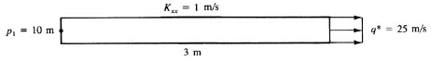
Fig-6

- Write short notes on the following:
- Transformation matrix in space Truss element 3M
- Dynamic response of bar element 3M
- Finite element formulation of 1D flow problems 4M

-- 00 -- 00 –

